;.Microsoft Multi-Tenant Organization
Below you will find details on how Microsoft Multi-Tenant Organization has been set up and how it impacts collaboration features between tenants.

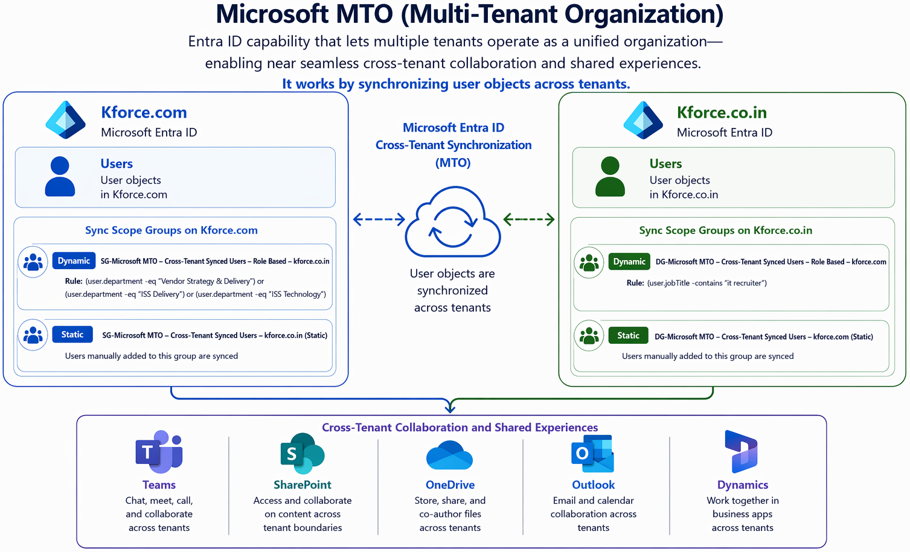

- What is Microsoft MTO?
Microsoft MTO is an Entra ID capability that lets multiple tenants operate as a unified organization—enabling near seamless cross-tenant collaboration and shared experiences. It works by synchronizing user objects across tenants.

- How is Microsoft MTO enabled on Kforce.com and Kforce.co.in?

MTO has been set up to only sync members of the following security groups.

  - Kforce.co.in

    - DG-Microsoft MTO - Cross-Tenant Synced Users - Role Based - kforce.com
This group is a dynamic group. Any user with the following job title attribute is automatically added to this group and automatically synced.
Rule: (user.jobTitle -contains "it recruiter")

    - DG-Microsoft MTO - Cross-Tenant Synced Users - kforce.com

This group is a static group. Any user manually added to this group will automatically be synced.

  - Kforce.com

    - SG-Microsoft MTO - Cross-Tenant Synced Users - Role Based - kforce.co.in
This group is a dynamic group. Any user with the following Department attribute is automatically added to this group and automatically synced.
Rule: (user.department -eq "Vendor Strategy & Delivery") or (user.department -eq "ISS Delivery") or (user.department -eq "ISS Technology")

- SG-Microsoft MTO - Cross-Tenant Synced Users - kforce.co.in
This group is a static group. Any user manually added to this group will automatically be synced.

- What happens after accounts are synced?

Microsoft MTO uses cross-tenant sync to create “Guest” accounts in respective tenants but labels them as “Members”. By labeling these synced accounts as members, in most scenarios, they are considered regular accounts, so labels associated with Guest or External are removed.

Synced accounts start to show up in Outlook address book, Teams chat, SharePoint/OneDrive share options as “regular” accounts.

- How can I tell if a user has been synced or not?

If a user account has not been synced, you will most likely notice “external” or “guest” account labels next to their names or even not see them at all in Outlook or Teams.

Example of non-synced accounts might appear in tenants.
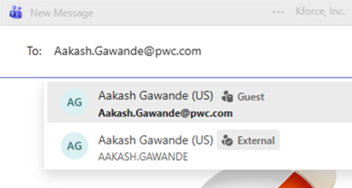

- What action should I take if I notice a user account that should be synced but it isn’t?
Please open a ticket with TechnicalSupport@kforce.com requesting that account be synced between tenants. (Please cc dnyaneshwar.karande@kforce.co.in)

